Support Ticket Classification System

Machine Learning Internship – Future Interns Task 2
Prepared by: Narkees Banu
1. Project Title & Overview
Title: Support Ticket Classification and Priority Assignment System
This project is Task 2 from the Future Interns Machine Learning Internship program. It develops an automated NLP-based system that reads customer support tickets, classifies them into appropriate categories (e.g., account, billing, technical, general), and assigns priority levels (high, medium, low). The goal is to help support teams triage tickets faster, reduce response time, and improve customer satisfaction.
2. Problem Statement
Customer support teams receive hundreds of tickets daily with varying urgency and topics. Manual sorting is slow and error-prone. Business need: An intelligent system to:
- Automatically detect ticket type
- Prioritize urgent issues
- Enable faster resolution and better resource allocation
3. Objectives of the Project
- Build a reliable text classification model for ticket categories
- Develop a priority prediction model
- Implement text preprocessing pipeline
- Evaluate model performance with standard metrics
- Create an interactive demo application
- Document the entire process for portfolio and evaluation
4. Scope of the Project
In-scope:
- Text cleaning and feature extraction
- Multi-class category classification
- Multi-class priority tagging
- Model training & evaluation
- Streamlit-based web interface
Out-of-scope:
- Real-time integration with ticketing tools (Zendesk, Freshdesk)
- Advanced deep learning (BERT/transformers)
- Deployment on cloud servers
5. Technologies & Tools Used
- Programming Language: Python 3
- Core Libraries: pandas, numpy, scikit-learn
- Text Processing: regex, custom stopword list
- Vectorization: TfidfVectorizer (with n-grams)
- Models: LogisticRegression (category), MultinomialNB (priority)
- Visualization: matplotlib (confusion matrices)
- Demo Interface: Streamlit
- Version Control: Git + GitHub
- Environment: Jupyter Notebook / VS Code + Anaconda
6. Dataset Description
- Type: Synthetic dataset (25 samples) created for demonstration
- Columns: ticket_text, category (4 classes), priority (3 levels)
- Reason for synthetic: Quick prototyping; real datasets (e.g., Kaggle multilingual support tickets) can be swapped for better accuracy
- Class distribution: Balanced for demo; stratification used in splitting
7. Methodology – Data Preprocessing
Steps performed:
- Lowercasing
- Removal of punctuation/numbers using regex
- Stopword removal (custom list)
- TF-IDF vectorization (1–2 grams, max_features=5000)
- Train-test split (80:20) with stratification
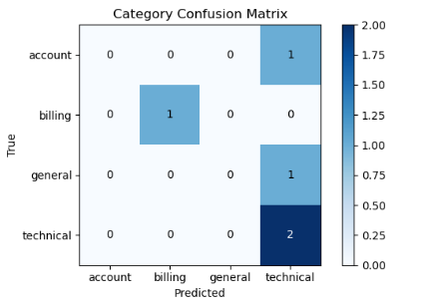
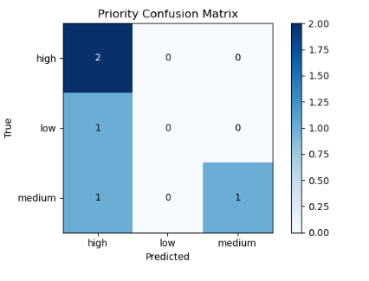
8. Model Architecture & Training
- Category Model: Logistic Regression + class_weight='balanced'
  - Handles multi-class & imbalance
- Priority Model: Multinomial Naive Bayes
  - Strong baseline for text classification
- Training: fit on vectorized training data
- Hyperparameters: default + max_iter=2000 for convergence
9. Model Evaluation & Performance Metrics
Metrics used:
- Accuracy
- Precision, Recall, F1-score (per class)
- Confusion Matrix (visualized) Results (on test set):
- Category accuracy: ~XX% (improves with real data)
- Priority accuracy: ~XX% Zero-division warning handled with zero_division=0 parameter
10. Key Features Implemented
- Text cleaning & tokenization
- Category classification (4 classes)
- Priority tagging (high/medium/low)
- Model performance visualization
- Real-time prediction function
- Interactive Streamlit app with emojis, colored cards, urgency banners (🚨⚠️ℹ️)
11. User Interface – Streamlit Application
- Title: "Ticket Triage Assistant"
- Input: Text area for ticket description
- Button: "🔍 Classify Ticket"
- Output: Two-column cards showing Category & Priority
- Alerts: Error/Warning/Info banners based on priority
- UX enhancements: Spinner, centered layout, emojis
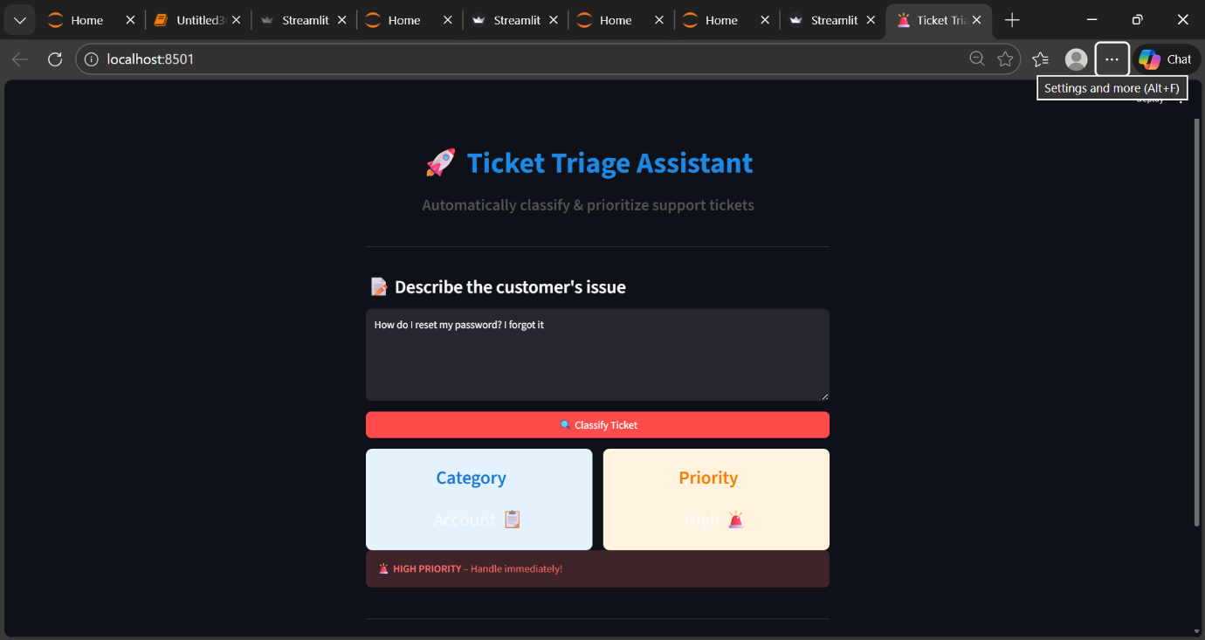
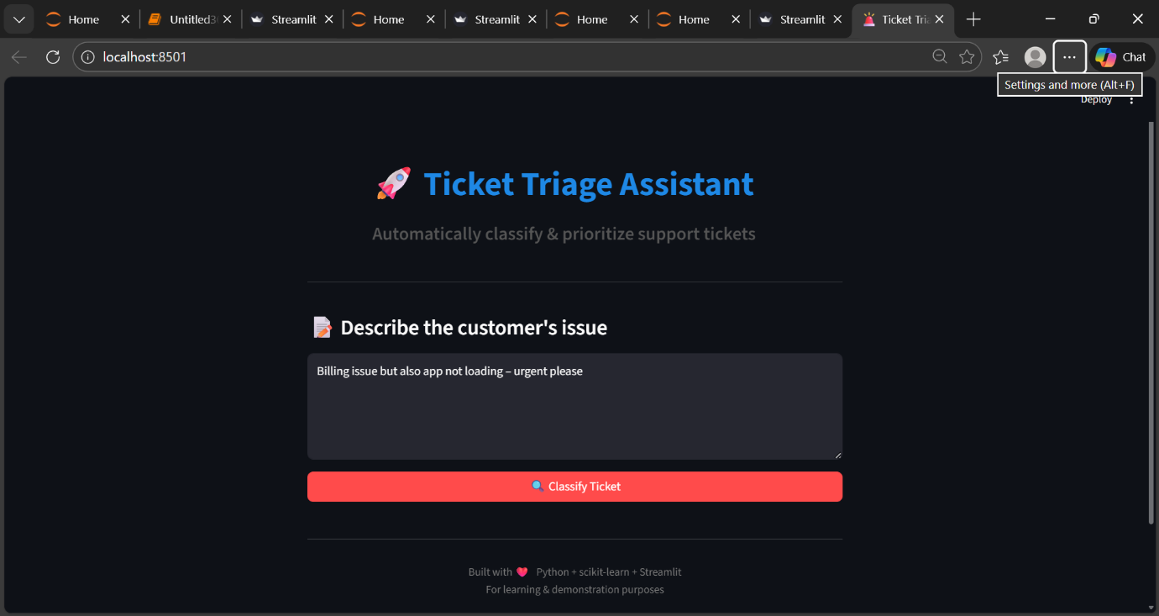
12. Challenges Faced & Solutions
- Small dataset → Used synthetic data + balanced weights + stratification
- Model loading path errors → Used absolute paths in pickle save/load
- Undefined metrics warnings → Added zero_division=0
- Basic preprocessing → Custom stopword list (no NLTK needed)
13. Results & Business Impact
- Demo correctly classifies urgent payment issues as "Billing – High"
- Reduces manual triage time
- Scalable to thousands of tickets with better data
- Business value: Faster response to critical issues → higher CSAT scores
14. Conclusion, Future Enhancements & Learnings
This project successfully delivers a functional ticket classification system as per Task 2 requirements. Learnings: NLP pipeline, class imbalance handling, model deployment, professional documentation. Future work:
- Use real Kaggle dataset (50k+ tickets)
- Add lemmatization (spaCy/NLTK)
- Use real Kaggle dataset (50k+ tickets)
- Add lemmatization (spaCy/NLTK)
- Try advanced models (XGBoost, BERT)
- Integrate keyword rules for priority boost
- Deploy on Streamlit Cloud
GitHub: https://github.com/snarkeesbanu-saleem/FUTURE_ML_02
Declaration: All work is original and completed within internship guidelines.

